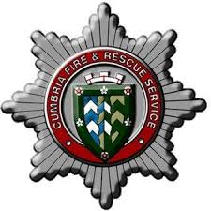
Cumbria Fire & Rescue Service
Person specification Form – CM Process

Name:

Please use the following headings to outline how you meet the person specification for this role:

Experience – Essential
Hold the post of competent operational Firefighter or above

Experience of working with teams and individuals to achieve their objectives

Experience of maintaining activities to meet requirements

Experience of taking responsibility for effective performance

Experience of supporting individual development.

Experience of investigating and reporting on events to inform future practice

Experience of supporting people to resolve operational incidents.

Experience of informing and educating the community to improve awareness of safety matters.

Experience of contributing to Fire Safety solutions to minimise risks to the Community.

Knowledge/ Understanding - Essential
A knowledge of statutory requirements affecting role.

A knowledge of Health and Safety legislation and statutory requirements.

A clear understanding of the risk concept and how it can be applied within a proactive safety culture.

Understanding of equality legislation and its application in relation to the duties of a supervisory management post.

A good knowledge and understanding of Incident Command, and Command Support at operational incidents.

A knowledge of disciplinary, grievance and performance management procedures.

An understanding of how performance management impacts upon organisational performance

Key Skills and Behaviours
Ability to demonstrate a comitment to CCC/CFRS behaviours

Ability to lead the work of teams and individuals to achieve their objectives.

Ability to support the iimplementation of change

Ability to maintain activities to meet requirements.

Ability to take responsibility for effective performance.

Ability to communicate effectively at all levels, with the ability to use a wide range of communication techniques.

Ability to utilise I.T systems for reports, performance management, monitoring etc.

Personal integrity with the ability to demonstrate high personal standards.

Evidence of Continual Personal Development.

Able to develop self, teams and individuals to enhance work based performance.

Other
Ability to travel throughout Cumbria and beyond including overnight stays where necessary.

