STEM in the Early Years: Science
Lava Lamps Activity
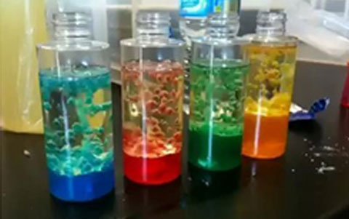

What you need for this activity:
- Plastic bottles
- Cooking oil
- Washing up liquid
- Food colouring
- Water
- Measuring jug
- Alka-Seltzer tablets

What to do:
- Quarter-fill a small clear plastic bottle with water and replace the lid. Encourage the children to shake the bottle and talk about what they see.
- Then add a few drops of food colouring to the bottle, enough to make a strong colour. Talk about what happens to the water when the bottle initially is kept still and then when it is shaken.
- Add the same amount of oil as water to the bottle. Put the lid on and shake. Watch what happens when the oil settles. Let the children repeat this, observe and talk about what is happening.
- Then add a few drops of washing up liquid, shake and see what happens.
- Fill another bottle, this time with twice as much oil as coloured water. When the oil and coloured water have separated, add half an Alka-Seltzer tablet. Observe and talk about what happens.

Adapting the activity:
1. Take a shallow tray outside and fill with water. Add 4 or 5 drops of cooking oil and watch what happens.
2. Swirl the water with a stick and see what happens.
3. Pour a little cooking oil into a small bowl and add enough food colouring to make a strong colour and mix well. Make several oils of different colours.
4. One by one pour the coloured oils into the tray of water and observe what happens. Allow time to see the effect of one colour before adding another one.

Key Science Concepts
- Oil and water do not mix. Even if you shake the bottle the oil will immediately separate from the water as soon as it settles.
- Oil only likes oil so it will only stick to the oil and water only likes water and so it will only stick to the water.
- The oil always floats on top of the water because the oil has a lower density than water.
- Washing up liquid likes oil and water and so it sticks to them both. It grabs the oil and the water and joins them together.

Vocabulary
- Encourage children to use words like mix, shake, swirl, change, dense, attract, molecules.
- Emphasise science process words like experiment, describe, compare, and observe.

