STEM in the Early Years: Technology
Torchy Tech Activity
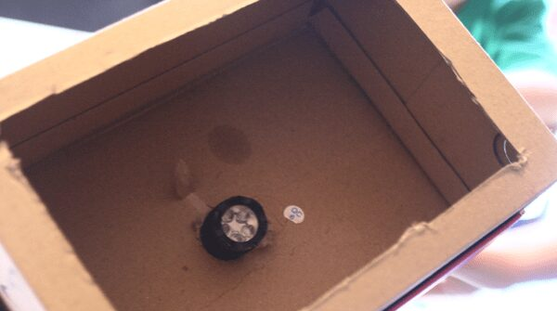
What you need for this activity:
- Shoe box or similar
- Battery operated torch
- Masking tape
- Black card cut to the same dimensions as the box
- Skewer or similar
- Cork board or polystyrene tray
- Blanket or large piece of thick material

What to do:
- Before the activity, cut a hole in the base of the shoe box that will be just wide enough to push the end of the torch through.
- Explore the torch with the children. What is it, how does it work, what do we need torches for?
- Introduce the idea of power being provided by the batteries. What do the children think will happen if you take the batteries out? Were they right? Explore the on/off buttons on the torch.
- Highlight the importance of never shining a torch directly in someone’s eye.
- Explore what happens when the torch is shone around the room and how the light moves. Crawl under the blanket and shine the torch again. Is the light different?
- Talk about making a light box using the torch. Help the children to push the torch through the hole in the box so that the light will project into the box. Tape it in place.
- Place the cork board or polystyrene tray under the black card and make small holes in it.
- Attach the card to the front of the box and tape in place.
- Turn the torch on and direct the box towards a blank wall or ceiling.

Adapting the activity:
1. Using the bottom of a shoe box, cut out a large rectangle from the bottom panel, leaving about a 1½ inch border around the edges. Cover the opening you made with tracing paper or greaseproof paper and secure it with tape. This is your shadow theatre.
2. From the other, open end, you need to prop or hold a flashlight inside the box and shine the light on the paper.
3. Place an object between the flashlight and the paper and see its shadow projected on the outside of the theatre.
4. You can show the children how to move their hands and fingers to make shadow puppets. Alternatively, put on old sock on their hand to make a simple sock puppet.
5. Older children can also make simple puppets, cut out of card, and fastened to lolly sticks which they can use in their shadow theatre.

Key Technology Concepts
- Batteries are a power source to make objects like torches work.
- Torches have on / off buttons make sure that the batteries do not run out of power quickly.

Key Science Concepts
- A shadow is made when an object blocks the light.
- You can change the shape of a shadow by moving and turning your body or the object making the shadow or by moving the light source.

Vocabulary
- Encourage children to use words like shadow, puppet, theatre, torch, light, shine, outline, shape, and dark.
- Emphasise science process words like describe, compare, notice, and observe.

